**CCT College Dublin**

**Assessment Cover Page**

|  |  |
| --- | --- |
| **Module Title:** | Strategic Thinking |
| **Assessment Title:** | Strategic Thinking – CA2 |
| **Lecturer Name:** | James Garza |
| **Student Full Name:** | Priya Arvind  Ivan Saravanja |
| **Student Number:** | sbs23062  [sbs23026](mailto:sbs23026@student.cct.ie) |
| **Assessment Due Date:** | 14 November 2023, 11:59 PM |
| **Date of Submission:** | November 14th |

**Declaration**

|  |
| --- |
| By submitting this assessment, I confirm that I have read the CCT policy on Academic Misconduct and understand the implications of submitting work that is not my own or does not appropriately reference material taken from a third party or other source. I declare it to be my own work and that all material from third parties has been appropriately referenced. I further confirm that this work has not previously been submitted for assessment by myself or someone else in CCT College Dublin or any other higher education institution. |

**Content (has to be changed)**

Introduction 2

1. Objectives 2

2. Technologies used 2

3. Machine Learning models 3

Data Understanding 3

1.About the Dataset Dimensions: 3

2.Source 3

3.Combining two datasets into one 3

Exploratory Data Analysis 4

1. Feature Selection 4

2. Visual Exploratory Data Analysis 6

Data Preparation 11

Dimensionality Reduction 17

Models Building 19

1. Defining the problem statement 19

2. Determining the type of the machine learning 19

3. Decision Tree 19

4. KNN Classification 22

5. Logistic Classification and Random Forest: 23

Evaluation 24

Conclusion 25

References 26

**Introduction**

In our first continuous assessment, our group had to work collaboratively to apply project management methodology to the project through which we develop and execute all the acquired skills gained from classes. We were supposed to find the appropriate dataset, conduct explanatory data analysis, pre-process the data, implement at least one machine learning algorithm and present our findings and conclusions.   
  
Our second assignment was focused on improving everything that was done in the first assignment based on things we have learned in the classes.

Our project focused on loan defaulters and our report covers the different stages of the project, including data understanding, data preparation, data visualisation and machine learning implementation and evaluation. The goal of the project was to help a finance company to identify which loan applicants are likely to repay their loans and which ones are likely to default. By understanding the factors that lead to loan default, the company can make better decisions about who to lend money to.   
Overall, this project allowed us to apply our skills in data preparation, data visualisations and machine learning to a real-world problem, while also demonstrating our ability to work together and manage a project effectively.

1. **Objectives**

We have set a few objectives for this assignment:

* Predict the Contract status based on available dataset.
* Predict the Target variable - late payment – defaulter.
* EDA analysis to develop a basic understanding of risk analytics financial services.
* Creating a Machine Learning predictive models on 'contract status' based on available dataset.
* Understand and analyse the driving/Important variables behind loan default, i.e. the variables which are strong indicators of default.
* Identify patterns which indicate the client has difficulty paying their instalments, this ensure capable clients loan applications are not rejected.

1. **Technologies used**

During the assignment execution, we were using multiple libraries. Some of them are: pandas, sklearn.decomposition, numpy, seaborn, matplotlib, sklearn.preprocessing, sklearn.linear_model, sklearn.preprocessing etc.

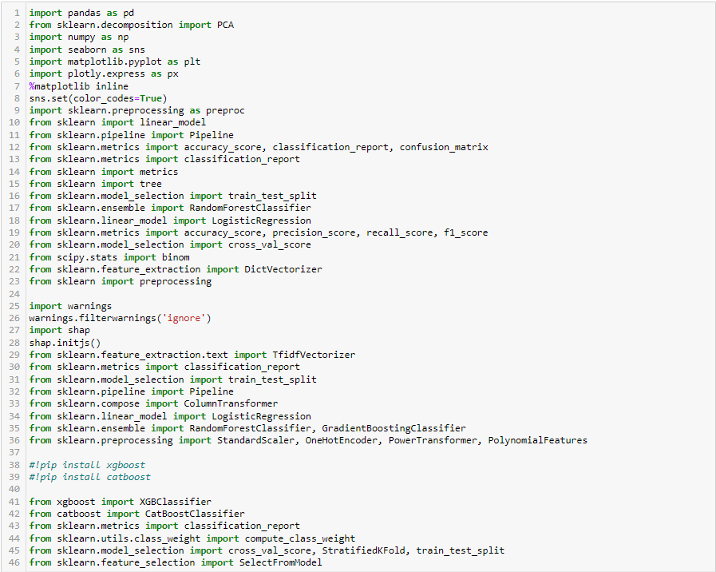

1. **Machine Learning models**

We used five machine learning models: Decision Tree, Logistic Regression, Random Forrest, KNN Classification…. **(@Priya, for you to check this part as I couldn’t run the notebook and it seems you were adding more models. Also, it seems you missed to add Decision Tree to Evaluation)**

**Data Understanding**

**1. About the Dataset Dimensions:**

Our dataset was a fairly large dataset, consisting of two datasets merged into one: “application_dataset.csv” and “previous_application.csv”. Initially, our dataset consisted of 1430154 rows and 158 columns. Out of those 158 columns, 85 of them were float64 type, 41 were int64 and 32 were object columns.

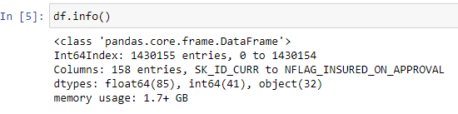

**2. Source**

We got our dataset from the Kaggle website. (DUTTA, 2020)

https://www.kaggle.com/datasets/gauravduttakiit/loan-defaulter

**3.** **Combining two datasets into one**

As mentioned above, we picked a large dataset that consisted of two datasets. We merged those two datasets namely “application_dataset.csv” and “previous_application.csv” based on the mutual column “SK_ID_CURR" and saved as "merged_dataset".

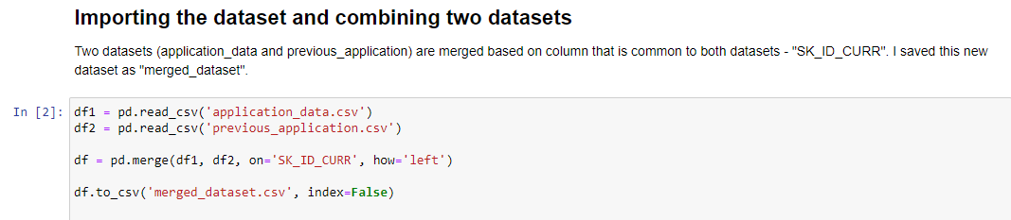

**Exploratory Data Analysis**

1. **Feature Selection**

Initial feature selection is based on basic exploration and we classified the feature <10 unique variables as Categorical and features with more unique values as Continuous, follows criteria and details of features.

* Common Variables in both the datasets:

Retained most of the common variables on both the datasets expect 4 dates and time features which are not important for our Target Variables.

|  |  |  |
| --- | --- | --- |
| Feature Name | Feature Description | Type |
| SK_ID_CURR | ID of the loan in our sample | Continuous |
| TARGET | Late Payment | Categorical |
| NAME_CONTRACT_TYPE | Identification if the loan is cash or revolving | Categorical |
| AMT_CREDIT | Credit amount of the loan | Continuous |
| AMT_ANNUITY | Loan annuity | Continuous |
| NAME_TYPE_SUITE | Who was accompanying the client when he was applying for the loan | Categorical |

* Uncommon variables in first Dataset 'Application_data.csv' Dataset:

|  |  |  |
| --- | --- | --- |
| Feature Name | Feature Description | Type |
| FLAG_OWN_CAR | Flag if the client owns a car | Categorical |
| FLAG_OWN_REALTY' | Flag if the client owns a house or flat | Categorical |
| CODE_GENDER | Number of children the client has | Categorical |
| NAME_EDUCATION_TYPE | Level of highest education the client achieved | Categorical |
| AMT_REQ_CREDIT_BUREAU_HOUR | Number of enquiries to Credit Bureau about the client one hour before application | Categorical |
| NAME_FAMILY_STATUS' | Family status of the client | Categorical |
| NAME_HOUSING_TYPE | What is the housing situation of the client (renting, living with parents, ...) | Categorical |
| NAME_INCOME_TYPE | Clients income type (businessman, working, maternity leave,…) | Categorical |
| CNT_CHILDREN | Number of children the client has | Categorical |
| REGION_POPULATION_RELATIVE' | Normalized population of region where the client lives (higher number means the client lives in the more populated region) | Continuous |
| AMT_INCOME_TOTAL | Income of the client | Continuous |
| DAYS_BIRTH' | Client's age in days at the time of application | Continuous |
| DAYS_EMPLOYED' | How many days before the application the person started current employment | Continuous |
| DAYS_REGISTRATION' | How many days before the application did the client change his registration | Continuous |

First dataset contained the maximum number of features and selected features with a strong correlation with Target variables and less Nullity <50%.

* Uncommon variables in second Dataset 'previous_application.csv' Dataset

selected features with a strong correlation with Target variables and less Nullity <50%.

|  |  |  |
| --- | --- | --- |
| Feature Name | Feature Description | Type |
| SK_ID_PREV | ID of previous credit in Home credit related to loan in our sample | Continuous |
| AMT_APPLICATION' | For how much credit did the client ask on the previous application | Continuous |
| NAME_CASH_LOAN_PURPOSE | Purpose of the cash loan | Categorical |
| NAME_CONTRACT_STATUS' | Contract status (approved, cancelled, ...) of a previous application | Categorical |

1. **Visual Exploratory Data Analysis**

* **Exploring uni-variable Gender, Age, Type of Education, and income group who availed loan Services.**

Females are the majority availed of loans when compared with men. The secondary education category is the highest availed of loan. The < 30 age group are the highest number of availed loans.

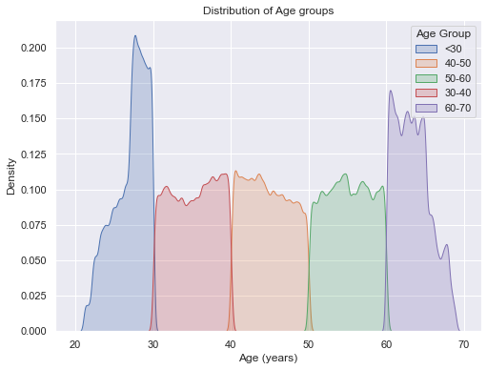

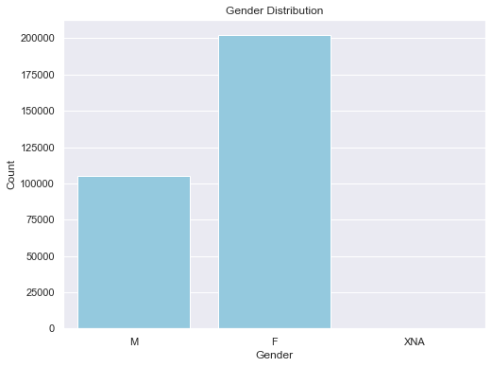

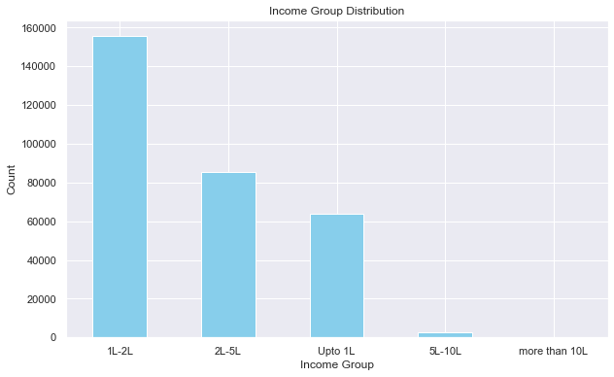

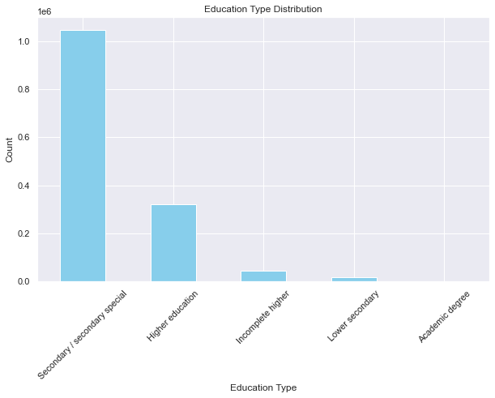

We used countplots ast they are suitable for our data, since we wanted to visualise distribution of categorical data. And show counting of each category. We used grid for better visibility and we used skyblue color as it’s neutral and easy on eyes, emphasizing count bars without being too distracting.

* **Exploring top 10 most common incomes compared to income median**

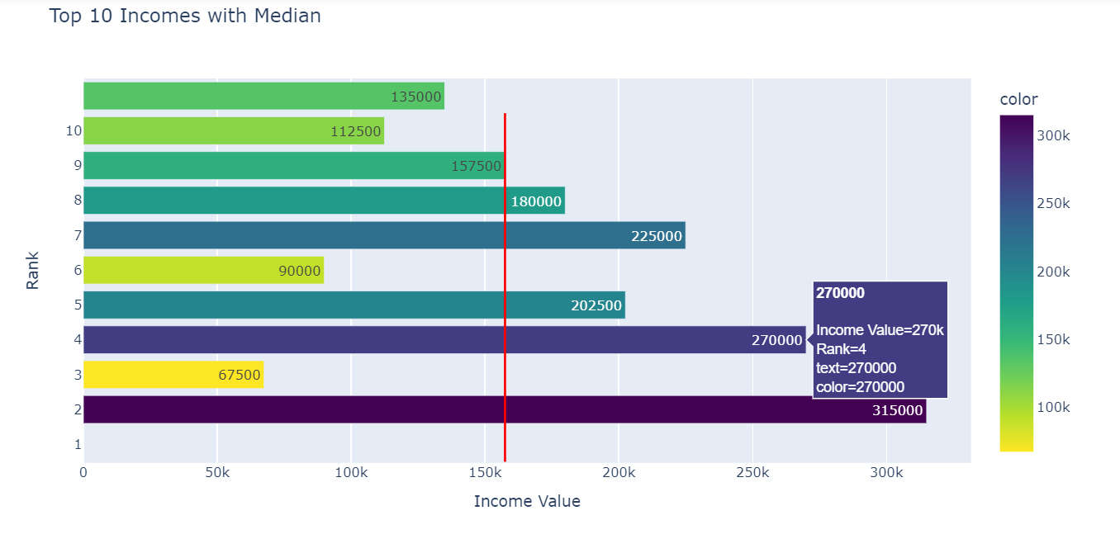

It is noticeable that the count of the incomes that are higher than the median is equal to the number of incomes lower than the median, which means that income doesn't make a difference on loans. We used this type of plot as we wanted to show relation between most common incomes and median of all incomes.

* **Exploring feature with Target feature defaulters**

The below plots are used to explore the correlation between Credit, Income and Annuity with the Target variable.

Payment defaulters are the majority low-income group of people.

Also, a higher credit amount is given to low-income people than higher income people



Also, we could see positive correlation between credit and annuity with respect to Target variable



Boxplot is used to explore outliners in Day of Employment with respect to the Target feature.

Payment Defaulters have been employed for an average of less than 3 years and having one outliner with a value 1000 years Repayers are employed for an average of 5+ years.



Age group of <30 earning less than 1L are most likely to have payment difficulties. Income group 5L-10L shows the least chances of payment difficulty. Income group 'more than 10L' are outliers, thus considering them as isolated events. 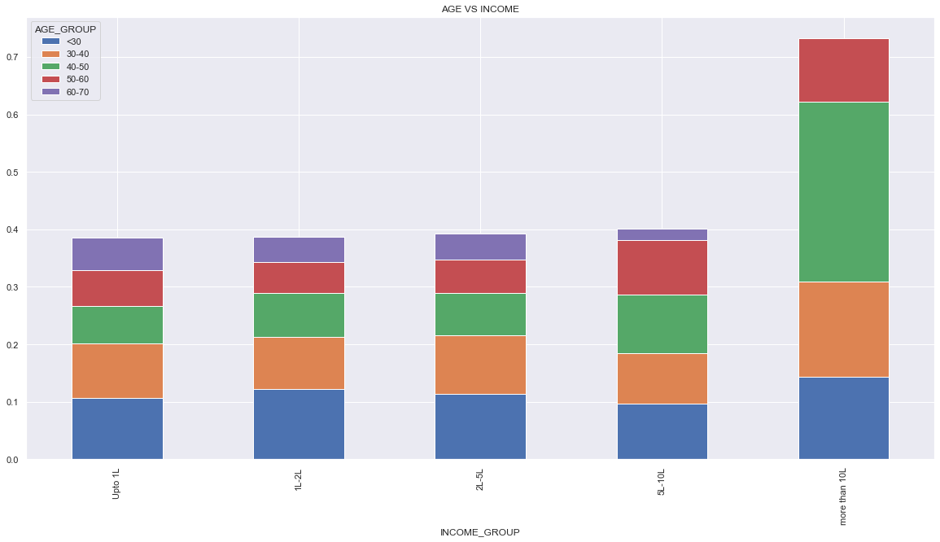

Lower secondary education-Civil Marriage & Single people are the riskiest categories exhibiting payment difficulty. Widows have shown less percentage of payment difficulty through all Education types. Academic degree Education type shows fewer chances of payment difficulty.

* **Correlation**

Credit and Annuity amount has the highest correlation. Days_Employed is less correlational with Number of Children(CNT_CHILDREN. Target doesn't show strong correlation among any features presented in the dataset.

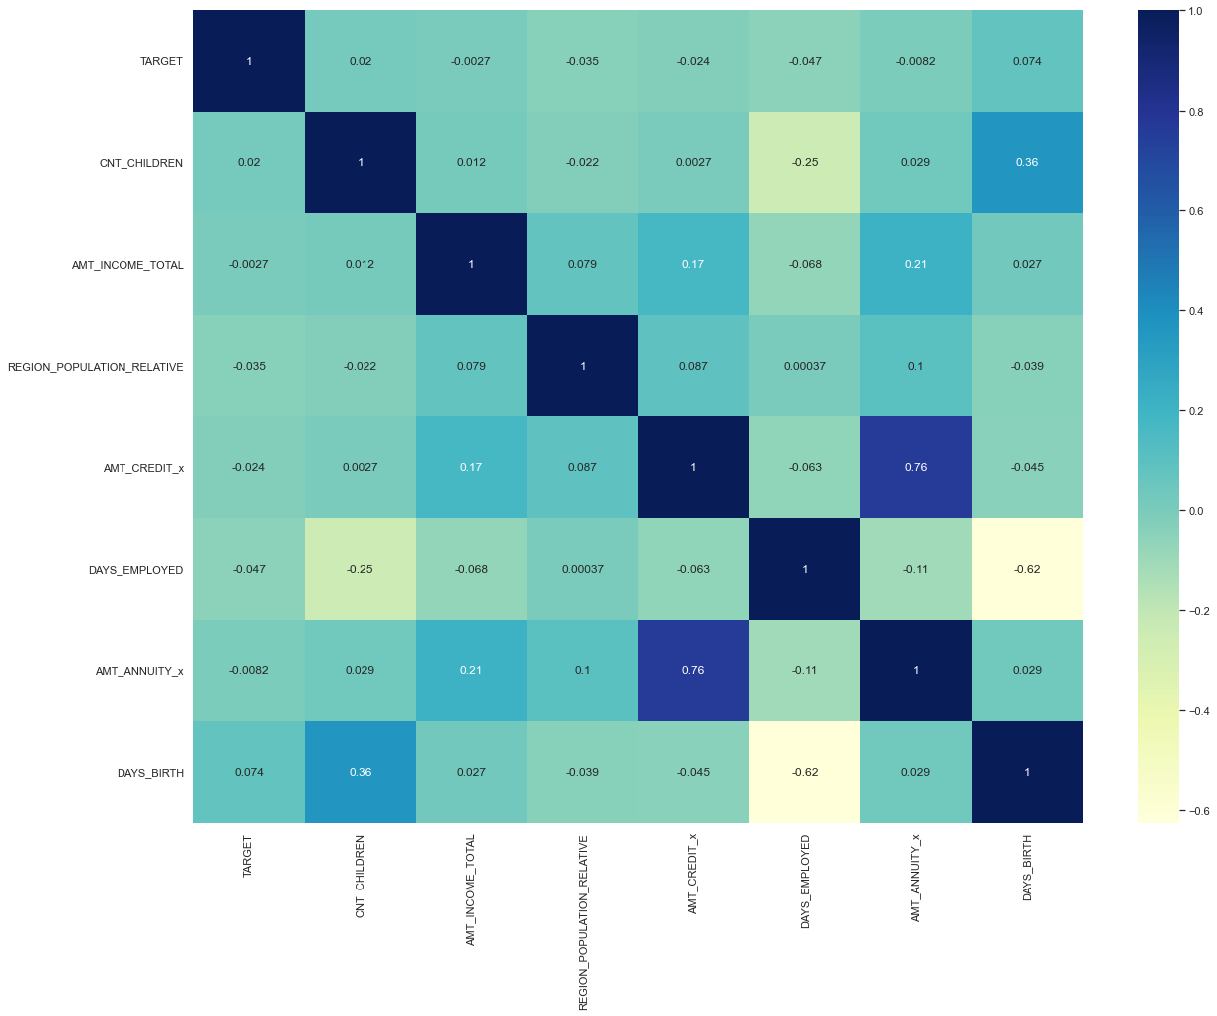

**Data Preparation**

1. **Removing NaN values**

Before removing the NaN values, we plotted a bar plot to visualise missing values in our dataset. Also, we provided a heatmap as well to show distribution of the missing values. We got the result that 9 attributes only have missing values and the one that has the most is “INCOME_GROUP”

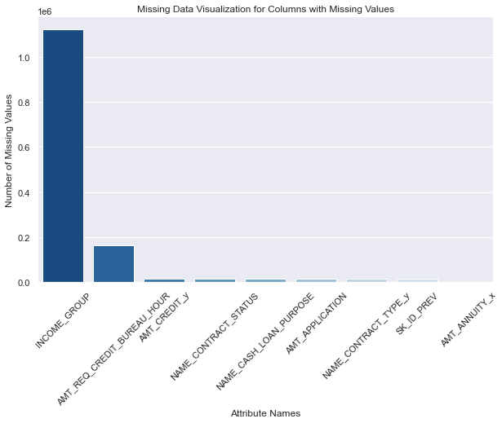

Since bar plots are easy to interpret, we picked this type of plot to provide clear representation of the extent of missing data for each attribute. We picked this color palette with shades, to emphasize columns with higher number of missing values with darker colors, to make them stand out.

After finding out which features contain missing values and in which percentage, we proceed to remove the missing values. Since our dataset contained more than a million rows, there were no issues with dropping a certain amount of rows and reducing the size of the dataset.   
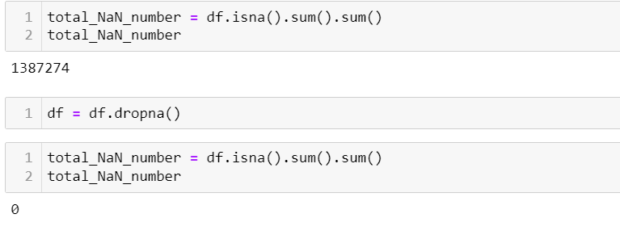

First, we calculated number of missing values and, after that, we removed rows with missing values and calculated number of them again. Now, the number of missing values was 0.

1. **Removing the Duplicates**

After removing the missing values, our next step was to remove the duplicates. Due to merging two datasets into one based on mutual, SK_ID_CURR column, new dataset contained many duplicates. What we did first was to check how many rows have duplicated ID.

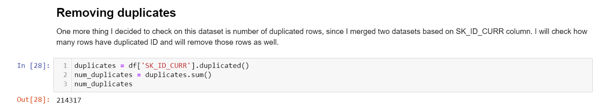

After checking the number of duplicates, we removed duplicated rows based on 'SK_ID_CURR' column. By using “keep=’first’”, we ensured that the first occurrence of each duplicate is retained while subsequent duplicates are removed. Our finalised dataset consisted of 307506 rows and 27 columns.

1. **Converting negative to absolute values**

During the data cleaning, we realised we have some columns in negative values which were showing how many days passed since some certain event (birth, employment day, registration day etc.). As those values mean the same thing if shown in positive values, we decided to convert them from negative to absolute values.

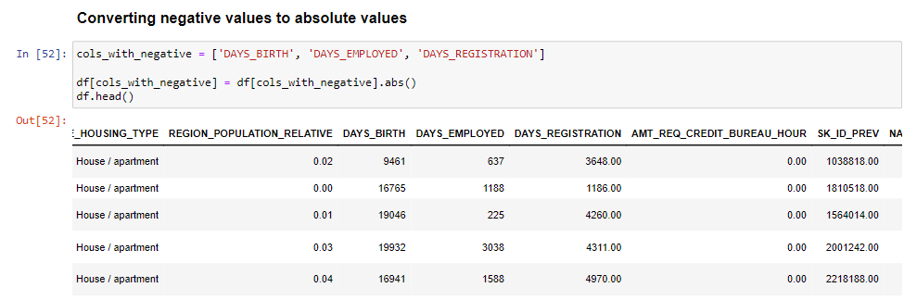

1. **Replacing categorical variables with numerical values**

Next important step in data preparation was to replace all the categorical variables with numerical values, to be able to run our machine learning models.

First thing we did was to check how many object columns we have in our dataset and which ones are them:

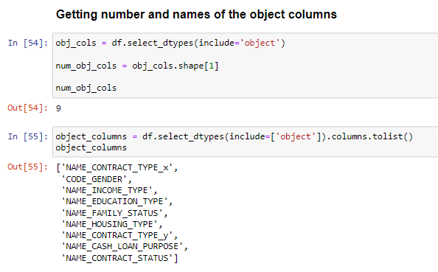

Next step was to get all unique values for each object column, to be able to replace them with numerical value:

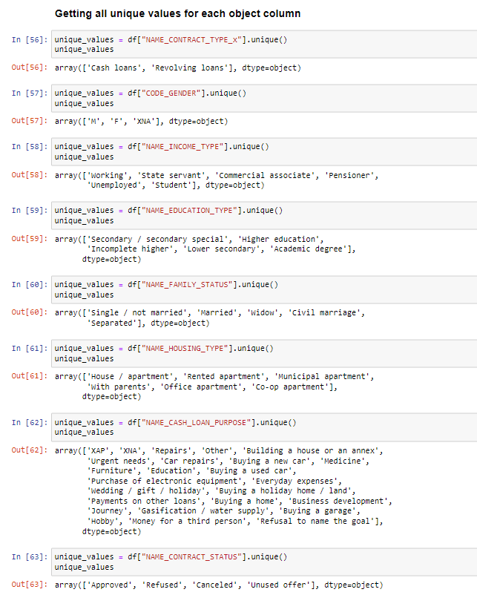

The last step in this process was to replace all unique categorical variables with numeric values. We used dictionary mapping that replaced specific unique values in the data frame with corresponding numeric values:

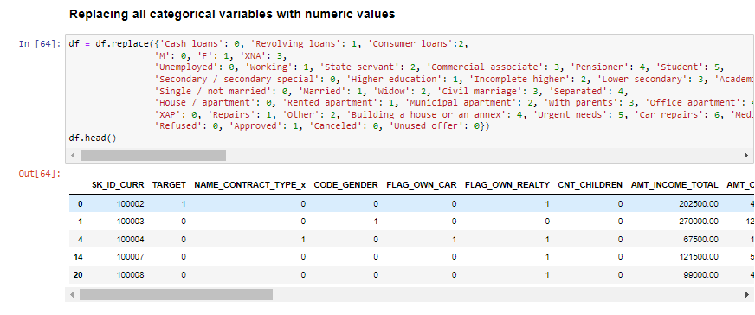

By doing this, our dataset was filled with numerical values only and was ready for machine learning models.

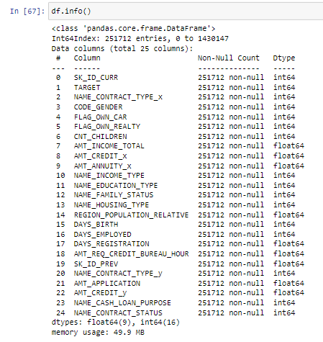

**Dimensionality Reduction**

Last step before building machine learning models was to reduce the dimensionality of the data. There are few reasons why dimensionality reduction is important in machine learning:

* “ It reduces the time and storage space required.
* It helps remove multi-collinearity which improves the interpretation of the parameters of the machine learning model.
* It becomes easier to visualize the data when reduced to very low dimensions such as 2D or 3D.
* It avoids the curse of dimensionality.
* It removes irrelevant features from the data, because having irrelevant features in the data can decrease the accuracy of the models and make your model learn based on irrelevant features.” (Abhigyan, 2020).

1. **Standard Scaling**

Once we started with Standard Scaling, we split the data frame into two parts: ‘X’ and ‘y’, based on dependent variable ‘TARGET’. By performing this split, we separated the input features (in ‘X’) from the target variable (in ‘y’).   
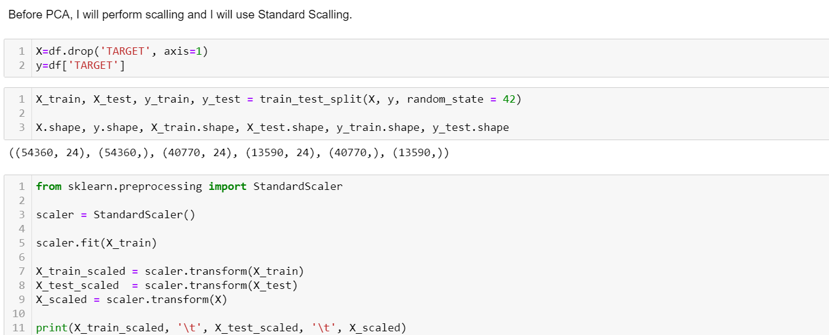

By using ‘StandardScaler’ we standardised the features by subtracting the mean and dividing by the standard deviation. All this is done to ensure that all the features have similar scales and to prevent certain features from dominating the model’s learning process.

1. **PCA**

Once we were done with scaling the data, we proceeded with the PCA. To improve PCA done in first CA, we used cumulative variance ratio to determine the number of components to retain in our PCA to get at least 95% of variability in our data. After we got the number, we created PCA object with the parameter of 4 principal components, then we transformed the scaled data into those components.

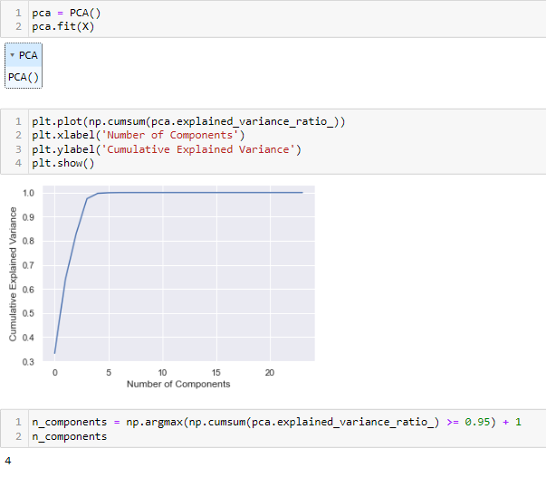

Besides that, we used a heatmap to visualise the values of the principal components which would help to identify patterns and relationships between the original features and the principal components.

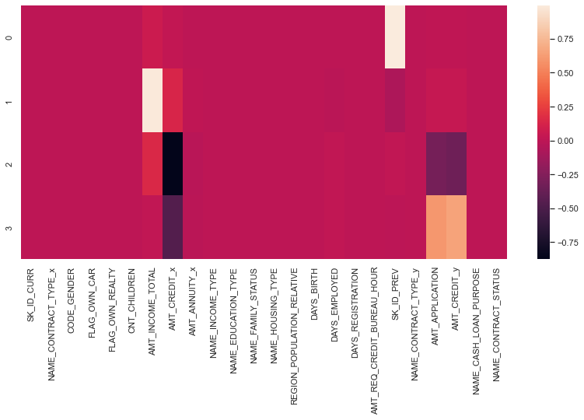

**Models Building**

1. **Defining the problem statement**

Create a Predictive model which can tell if the application contract status is successful and predict the defaulters.

1. **Determining the type of the machine learning**

After considering the characteristics of the problem we are trying to solve, the data we have and after executing the EDA, we decided to go with supervised machine learning classification models.

1. **Decision Tree**

We used this machine learning model on a dataset which was cleaned and pre-processed, however, we didn’t perform Scaling and PCA on it prior to building the model. We applied Scaling and PCA to other models in this assignment.

The target variable for this model was column 'NAME_CONTRACT_STATUS'.

The first step in creating the model was to define the feature columns (‘X’) and the target variable (‘y’).

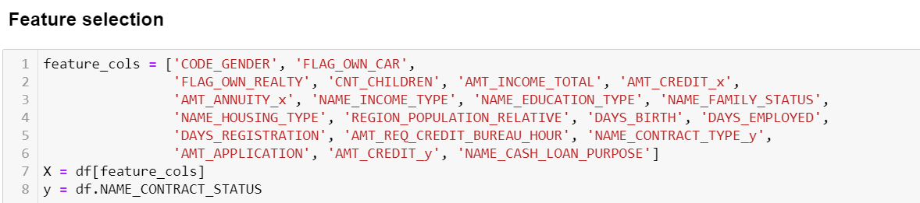

The target variable for this model was column 'NAME_CONTRACT_STATUS' and all other columns are listed as feature columns.   
In order to improve the scores, our next step was to use an ‘importance’ array to rank all the features based on their importance according to the RFE algorithm. By doing so, we were able to identify the most important features for further analysis. Then we used a code to get that list of features along with their respective ranks, starting with the most important feature.

For our analysis, we only used features that are within top 3 in the importance.

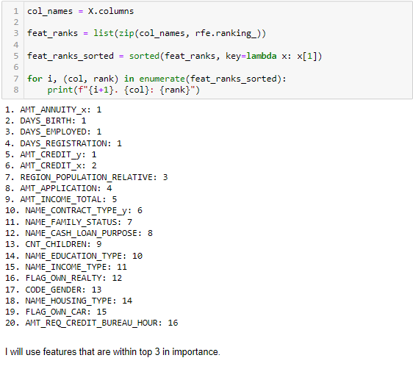

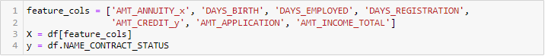 Our next step was to split dataset into training set and test set.   
In previous assignment, we were using 70/30 split but for this one, we decided to improve scores and check 80/20 split as well. Besides that, we used Gini to split the data in a way that minimizes impurity at each node.

* 70/30 split

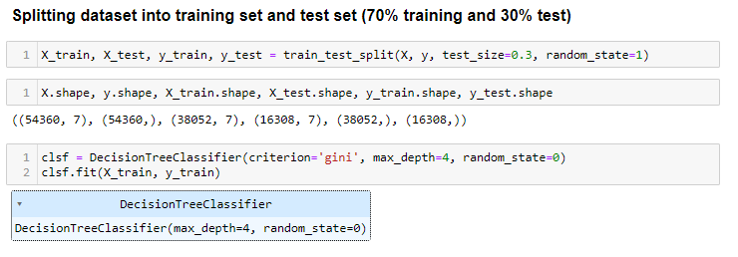

Scores improved only a little bit compared to CA1 and now our model had accuracy of almost 87.69%  
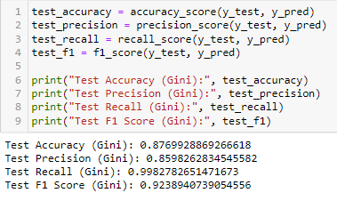

When checking test and train score, these were results:

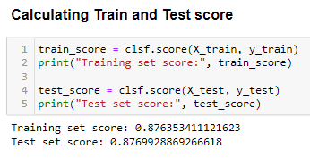

Training and Test cores are relatively close to each other and the difference between them is not significant. That means, it is less likely that the model is overfitting or underfitting. This model is pretty good at figuring out which applications are successful and which not, having test accuracy at 87.60% and test precision at 86.11%. F1 score tells us that model is good at balancing both, accuracy and completeness in its predictions.

* 80/20 split

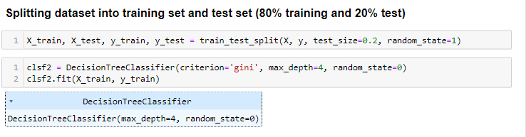

Scores were pretty much the same as with 70/30 split.

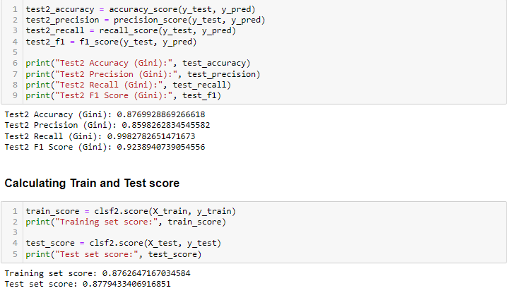

We picked Decision Tree model for this problem as we were dealing with categorical variables which didn't need much preprocessing and this model is really good with handling those. Also, it can provide feature importance, which helped us to identify which features are most influential in making predictions. Decision Tree provides as clear and interpretable model, which is also important advantage of this model. In the context of financial or application approval, interpretability is crucial as we would like to know why certain decision was made. Last but not least, Decision Tree can serve as good starting point for understanding our data, in terms of identifying key features and trends before potentially moving to more complex models, which we will do.

1. **Logistic Regression**

Before we started with Logistic Regression, we did preparation of the dataset by performing Standard Scaling and PCA, which is explained in steps above. The difference in performing those two steps changed the accuracy of our machine learning models and improved them significantly.

The other difference compared to CA1 was that we implemented Pipeline as well. We decided for this step due to multiple reasons – it helps in organising and streamlining ML workflow but it’s also useful when working in collaborative setting, like we were doing it now, as whole ML process can be reproduced consistently.

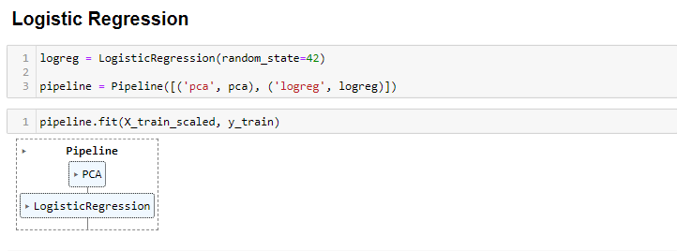

Accuracy of our model improved from 60.78% (even after using GridSearchCV) in CA1 to 92.06%.

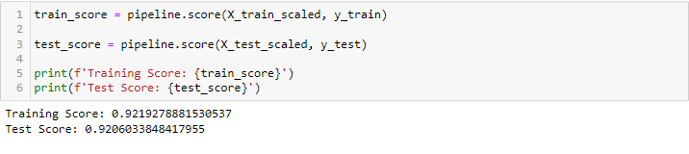

Training and Test scores are, again, close to each other and the difference between them is not significant, which means, it is less likely that the model is overfitting or underfitting. Also, model is pretty good taking into consideration accuracy at 92.06%, which is even better than Decision Tree.

We picked Logistic regression since this is binary classification problem and Logistic Regression is a good starting point since it's interpretable, easy to implement and can serve as baseline model, which will be case in our assignment.

1. **Random Forest**

We were using the same pipeline set previously and this model, also, reached really good scores.

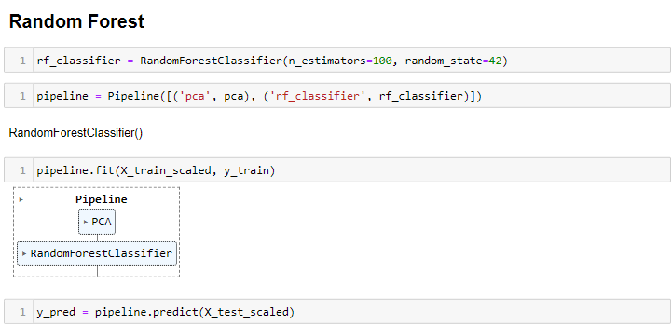

Accuracy of this model went up to 92.03%, compared to 76% in CA1.

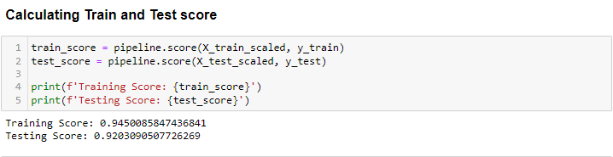

When it comes to training score - scores suggest that model perform really well on data it was trained on, which means that model has learned patterns in training data well. Testing score (92.03%) is saying that model's performance on new, unseen data is also quite good. In terms of overfitting and underfitting, training and testing scores are still reasonably close to each other, which shows good balance. It shows signs of slight overfitting, but it's still doing good job in generalizing to new situations.

We picked Random Forest because it's reliable in predictions due to using multiple decision trees. Also, it's good with handling overfitting as introduces randomness in its tree-building process and making the model more robust.

1. **KNN Classification**

**Evaluation**

To determine which model is the best, we need to consider multiple factors beyond just the accuracy scores. While accuracy is an important metric, it may not always provide the complete picture of a model’s performance. Based on the provided information, the KNN model with the test score of 92% appears to perform the best in terms of accuracy.

**Conclusion (has to be changed)**

Through exploratory data analysis, feature engineering, dimensionality reduction, and feature selection techniques, we gained insights into the dataset we have chosen before.

We trained and evaluated various machine learning models, including Decision Tree, Logistic Regression, Random Forest, and K-Nearest Neighbors (KNN) in order to see which one would give us the best predictions.

The results showed that the KNN model performed the best with an accuracy score of 92%, indicating its ability to effectively predict defaulters and contract status. However, further analysis is required to understand the underlying patterns and variables that contribute to loan default and successful application status.

To improve the models, it is recommended to conduct a more in-depth analysis of the important variables behind loan default, identify patterns indicating clients' difficulty in paying instalments, and refine the predictive model. This may involve exploring additional variables, conducting statistical tests, and utilizing more advanced machine-learning techniques.

By refining and building a better model, we can enhance our ability to predict defaulters and contract status accurately. This will enable us to make informed decisions in loan application evaluations, mitigate risks associated with loan default, and improve the overall success rate of loan contracts.

In conclusion, this assignment provided valuable insights into loan default and success application status. It highlighted the importance of analysing important variables, identifying patterns, and refining the predictive model to make more accurate predictions. By addressing these aspects, we can enhance decision-making processes, minimize default risks, and improve loan contract outcomes.

# References

Abhigyan, 2020. *Medium.* [Online]   
Available at: https://medium.com/analytics-vidhya/importance-of-dimensionality-reduction-d6a4c7289b92  
[Accessed 5 May 2023].

DUTTA, G., 2020. *Kaggle.* [Online]   
Available at: https://www.kaggle.com/datasets/gauravduttakiit/loan-defaulter?select=columns_description.csv  
[Accessed 15 April 2023].